Automatic Vehicle Signal Enabiling System

Vemuluri Praneeth Prasad
Information technology,
Chaitanya Bharathi Institute of Technology,
Hyderabad, India
Praneethlucky132@gmail.com
Sirisha Alamanda
Information technology,
Chaitanya Bharathi Institute of Technology,
Hyderabad, India
asirisha_it@cbit.ac.in

Abstract—Automatic signal enabling system is to make the indicators of the vehicle turn automatically on or off based on the predefined locations in maps in order to prevent the accidents which are prone only due to negligence in following few traffic rules, due to the laziness shown by the drivers in order to indicate the signal lights while shifting of lanes or turning on roads etc. We use UV sensors to detect the turn and LED’s as alternative to signals in vehicles.
Keywords—Automatic Vehicle Indicators, UV sensors, Raspberry pi 3.

Introduction
Every year many people die or many more are injured or disabled due to road accidents. The accidents occur due to negligence of drivers in following the road rules or not using the indicators or head lights etc., Many people have solved the issue of indicators of vehicle by making them automatic. This automatic indicating system include maps for user entering his source and destination which in turn gives the optimized directions for the user. The only thing the user needs to follow is the route given by the maps. It uses LED’s for our prototype which are alternatives for Indicators of vehicles and UV sensors for detecting the turn and uses MapBox directions API for getting the optimized directions. For every turn the map gives us the Direction along with the distance to the turn from the starting point(source) or from the turn. Taking the defined value for street speed as 30kmph. Now authors convert the distance into time which will in turn turns the indicators based on the time provided. Till the turn is detected the indicator will be turned on and once the turn is detected the Indicator will be turned off after 5 seconds. This is also extended to lane switching.

PROBLEM Definition
One major problem with many of the drivers is that they don’t utilize the indicators of the vehicle which confuses the drivers behind the vehicle. In many instances, particularly drivers of two-wheelers and less experienced drivers neglect the operation of indicators while taking turns. There are many vehicles signaling systems available in the market such as voice enabled or ORVM indicators etc., works manually which needs driver action to indicate the signals of the vehicles. So, the authors have proposed an automatic signal enabling system which make the indicators of the vehicle to turn on or off automatically without the intervention of the driver.

EXISTING SYSTEM
The existing turn indicator systems present in most of the vehicles are fully manually controlled systems. Moving further there are some automatic systems. Diving deep further into automatic systems, there are no such prototypes using maps. Voice detection is one of the methods in automatic systems.
The manual system is slow because the driver needs to make it work which becomes it slow or the driver may not use the indicators. Coming to the voice-based indicators the voice based module will just not hear the directions but every word of the driver, if there are more than one person and they are having a conversation, a word of left or right may cause the signaling system to malfunction. And every moment the voice module hears the voice and processes the word it hears and makes it more complex and time taking to resolve.

PROPOSED SYSTEM
The proposed system has mainly consisted of two tiers. One is software tier and the other is hardware tier. The software tier is responsible of taking the user input i.e the destination address and generating the directions provided by the route.

SOFTWARE TIER
The main aim of this tier is to get the directions from java script library and rest API service and crosscheck between them and give us the optimized directions tuple.

HARDWARE TIER
The hardware tier main aim is to convert the directions tuple for turning the indicators on or off by using UV sensors.

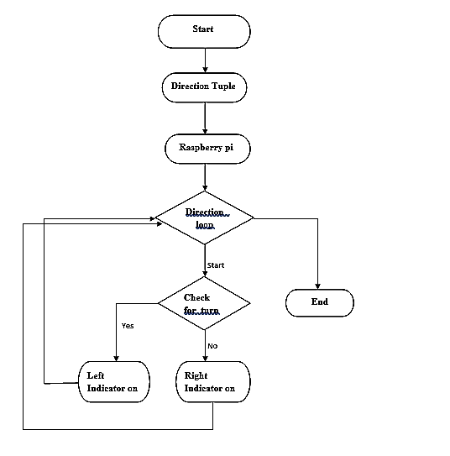
Fig. Flow of Hardware Tier

PYTHON LIRARIES USED

RPI.GPIO
Re
Time
Geopy
Beautiful Soup

RPi.GPIO is a popular Python library used on Raspberry Pi platforms to control GPIO pins. In addition to GPIO control, it is also used by many other libraries to query the Raspberry Pi hardware version as header pin layouts differed between certain versions. And, currently, it also provides some useful software PWM functionality on all GPIO pins.
RE stands for regular expressions. As authors cannot solely depend on the rest services output, authors considered the java script output. To parse the rest services output, authors used Regular Expressions for parsing the content of java script.
Beautiful Soup is a Python library for parsing structured data. It allows you to interact with HTML in a similar way to how you would interact with a web page using developer tools. Beautiful Soup exposes a couple of intuitive functions you can use to explore the HTML you received.

JAVA SCRIPT LIBRARIES USED
Mapbox is a JavaScript library for interactive, customizable vector maps on the web. It takes map styles that conform to the Mapbox Style Specification, applies them to
vector tiles that conform to the Mapbox Vector Tile Specification and renders them using WebGL. Mapbox GL JS is part of the cross-platform Mapbox GL ecosystem, which also includes compatible native SDKs for applications on Android, iOS, macOS, Qt, and React Native. Mapbox provides building blocks to add location features like maps, search, and navigation into any experience you create.

MODULES OF THE PROPOSED SYSTEM
The proposed system has 4 major modules, they include software for user interface, integration of user interface with raspberry pi, hardware setup for turning on/off the LED’s, cross checking with the directions provided by Java script library.

I) Software for User Interface
This is where the user enters source/current and destination point. For this to implement the authors have used mapbox javascript library for displaying the maps and getting the directions for given source and destination. Now the user has to select from different options for his transit (car for instance) which gives us different directions. To handle these types of scenarios we have different functions to handle them. One such case is driving by avoiding highways ignoring tollbooths gives one type of directions. Now the directions are shown to the users with the path in the map. These directions are transferred to backend or to raspberry pi once the user clicks on start navigation.

II) Integration of User Interface with Hardware
To integrate with hardware a code is written. This code is for detecting turns both left and right and turning on/off the LED’s. Some such cases are as follows:
1. What if the driver didn’t take turn as suggested by the application?
2. What if there is a road blockage in middle of the navigation path?
3. What if there is huge traffic?

III) Hardware (Raspberrypi3)
This part handles the working of UV sensors and LEDs by giving them the voltage required and plays an important role where it detects the turn by the rotation of the handle and turns the indicators on/off.

IV) Cross Checking with Directions
As authors cannot depend on the java script library for directions for optimized route. so, it also cross checks them with other maps through their rest services. we provide the source and destination to the rest services with the options given by the user. The output of the rest services could be both json and xml format. Now it uses web scraping to parse the output of the json and xml format in the output format of java script and check which gives us the better optimized path from source to destination. For doing this formatting into directions tuple we use beautiful soup.

V. EXPERIMENTAL RESULTS AND DISCUSSIONS

The efficiency of the proposed system is checked by conducting some experiments on real time maps.

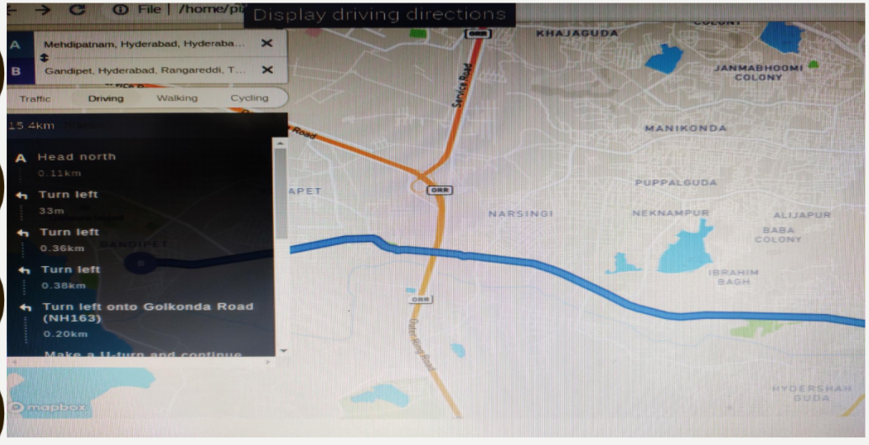
Fig. Directions from source to destination

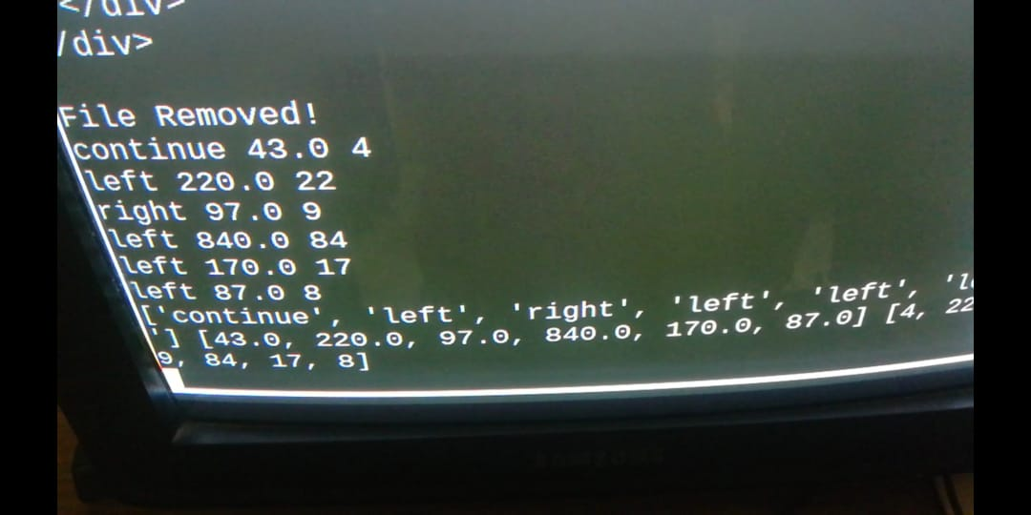
Fig. Directions retrieved to Raspberry pi

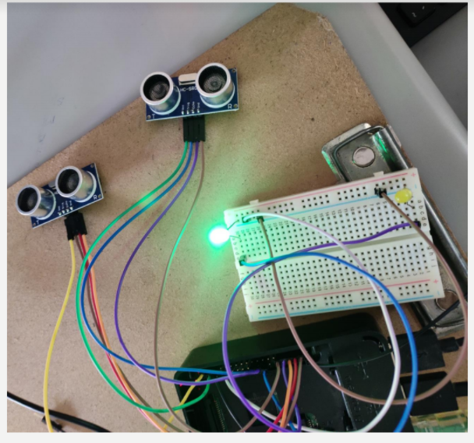
Fig. Automatically signal indicator on when it detected a turn ahead

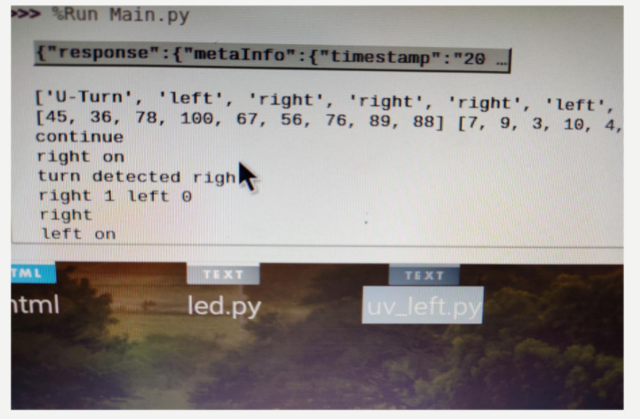
Fig. When detected a turn, raspberryPi returns signals

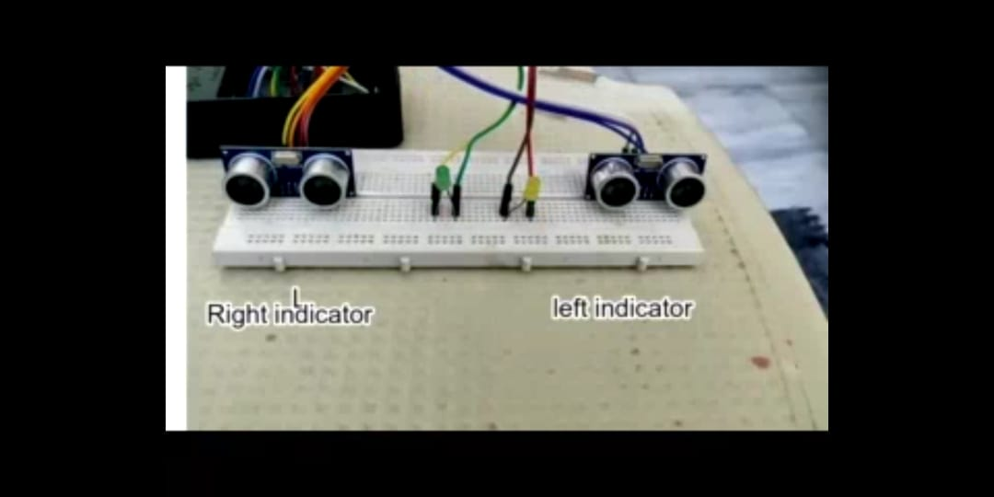
Fig. Hardware showing UV sensors and LED’s

The authors’ focus is to avoid the accidents that take place because of people forgetting the signal indicators. So, the proposed system has successfully addressed the drawbacks of not using the indicators by making the indicators of the vehicle to turn on or turn off automatically as per the pre detected turns in the route of the given destination of the driver. There is an alternative option if the user does not provide the destination. When a user is taking the turn the indicator of the vehicle turn on if the user did not turn the indicator.
The drawback of the proposed system is need of internet connectivity and there is a compulsory need of a display device to take the destination input from the driver which adds more cost to the proposed system. The ultraviolet sensors need to be checked for every two weeks. UV sensors are used for only shorter distance detection.

APPLICATIONS
- Lane switching
There are some lanes in the national highways and some speed limited in every lane. If we want to change from one lane to another lane, the indicator should be on. In this situation the proposed system can is used, no need to signal manually. Based on steering angle and based on route map left/right side indicator will be ON automatically.

- Ambulances
Ambulances are one of the emergency vehicles; in which driver will take the patients and drop at the destination point. By using this Automatic Vehicle Signal Enabling System ambulance driver will enter destination from current location and he does not need to press the indicator button on/off manually. Automatically indicators will on/off be based on predefined locations in map. It is very useful for ambulances.

3. Defense vehicles
The defense vehicles of the country should follow a route which must follow all the traffic rules. In this case the vehicle must move at extreme right or extreme left.

4. Autonomous vehicles
one of the best example of the use of the proposed Automatic Vehicle Signal Enabling System is autonomous cars. And while fully autonomous cars are undoubtedly still a few years away, several automakers are rolling out semi-autonomous systems that are getting ever closer to the idea of jumping inside the car and letting it take over from there. In this vehicles also will develop automatic indicators ON/OFF.

VI. CONCLUSION

The proposed system of automatic vehicle enabling overcomes the disadvantages of both manual type of indicators and voice-based indicators.
The proposed system can be extended to display-less device where the driver enters the destination part in his mobile and can be used for lane switching. Though the authors have used raspberry pi3 in the proposed solution, a dedicated PCB can be used for the system which effectively lowers the price.

References

- DESIGN OF SEMI AUTOMATIC SIGNAL INDICATOR FOR A TWO-WHEELER K. Divakara Murthy, V. Harshitha, Pedapudi Ashok, in St Peter’s Engineering College, Mechanical Engineering Department, Hyderabad, ISSN (PRINT): 2393-8374.
- AUTOMATIC VEHICLE TURNING INDICATOR, Vignesh.M, Dhanashekaran.V, Hemanth Kumar Reddy.V, Neelesh, Mrs.Preethi.V, SRM Institute Of Science And Technology, Chennai. 018 PUBLISHED: 27.02.2018 April 03, 2018 3102 9 ©2018.
- Richard I. Perlman, Norman G. Looper, ”Wireless Remote Vehicle Signal indicator For Supplementing Existing Vehicle Signal Indicators” , Patent Appl. No: US 6,677,856 B2, Jan. 13, 2004.
- Raiyan, Z., Nawaz, M. S., Adnan, A. K. M. A., & Imam, M. H. (2017). Design of an arduino based voice-controlled automated wheelchair. 2017 IEEE Region 10 Humanitarian Technology Conference (R10-HTC). doi:10.1109/r10-htc.2017.8288954.
- AUTOMATE VEHICLE CONTROL SYSTEM. By: M.Habibullah, Pagarkar, Kaushal Parekh, Jogen Shah, Jignasa Desai, Prarthna Advani, Siddhesh Sarvankar, Nikhil.
.

